Module 3: Critical Thinking Assignment

Chioma Chance

CSC500

06/29/2024

# Introduction

This assignment focused on our ability to develop Python programs to solve practical problems. The first part focused on calculating the total cost of a meal, which included an 18% tip and 7% sales tax. The second part addressed time calculations on a 24-hour clock, allowing the user to input the current time to calculate a time (after 50hrs) to set an alarm.

# Part 1: Meal cost calculation

**Pseudocode:**

START

PROMPT user to input the meal price

STORE the meal price in meal_price

CALCULATE tip as meal_price * 0.18

CALCULATE tax as meal_price * 0.07

CALCULATE total_price as meal_price + tip + tax

DISPLAY “The total amount spent at the restaurant was:” followed by total_price formatted to two decimal places

END

**Source code:**

# total price of food at resturant

meal_price = int(input('Enter charged amount:\n'))

# calculations

tip = meal_price * 0.18

tax = meal_price * 0.07

# totaled

total_price = meal_price + tax + tip

print(f'The total amount spent at the resturant was: ${total_price:.2f}')

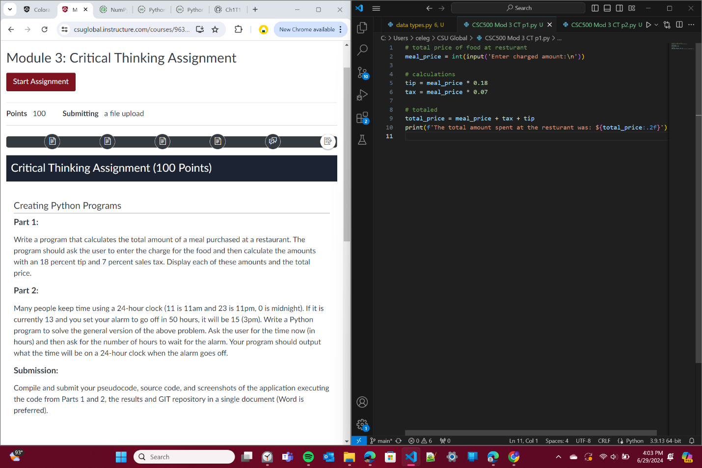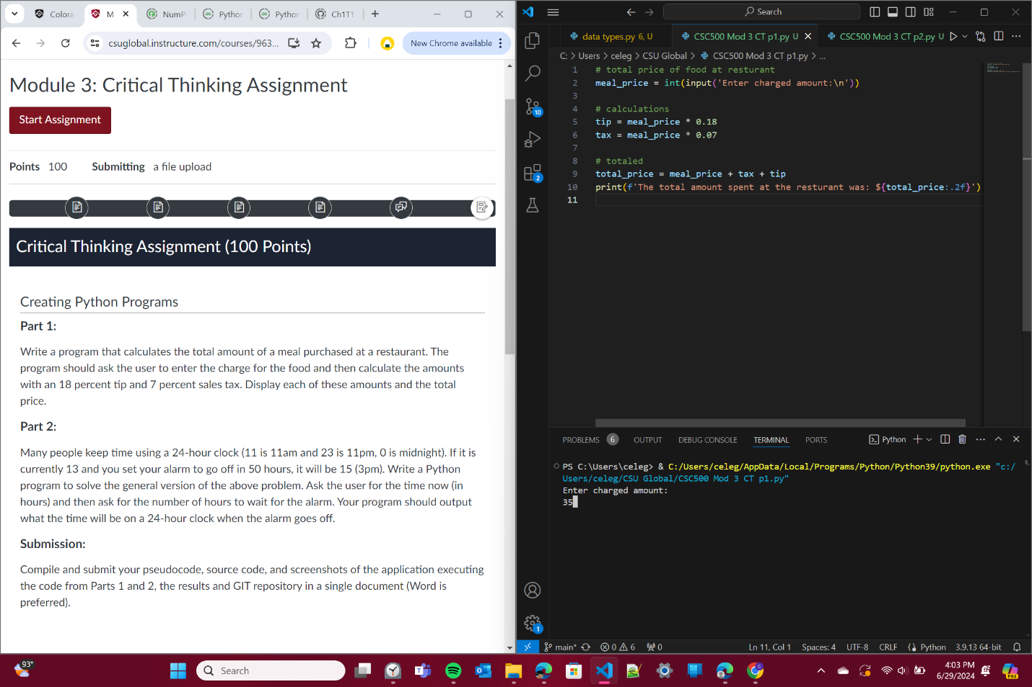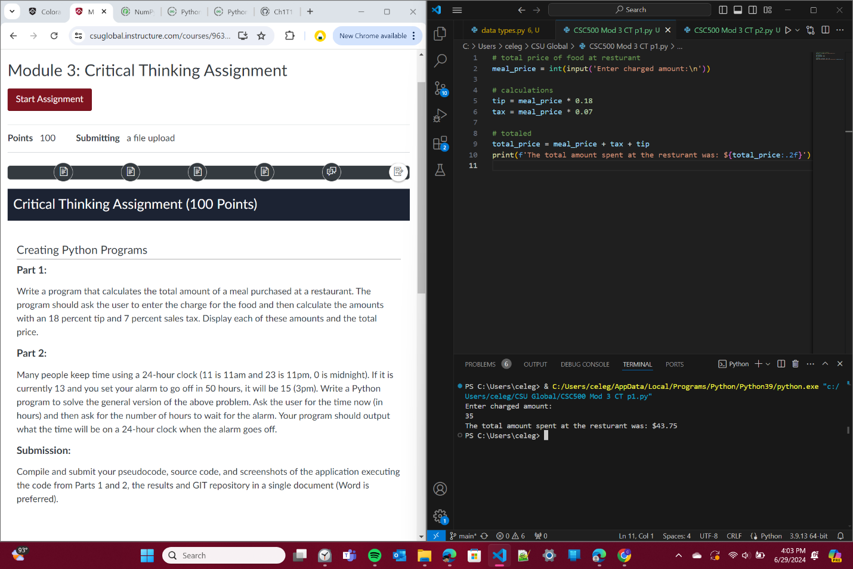

# Part 2: 24-hour Clock Alarm

**Pseudocode:**

START

PROMPT user to enter the current time with numbers (0-23)

STORE the input in current_time

SET alarm to current_time + 50

IF alarm is greater than or equal to 24

SET alarm to alarm modulo 24

END IF

DISPLAY “If it is currently” followed by current_time “:00, after 50 hours your alarm will go off at” followed by alarm “:00”

END

**Source code:**

# input for time of day

current_time = int(input('Enter the current time (0-23):\n'))

# alarm set to go off in 50 hrs

alarm = current_time + 50

# adjust for if greater than 24

if alarm >= 24:

    alarm %= 24

# print

print(f'''If it is currently {current_time}:00,

      after 50hrs your alarm will go off at {alarm}:00''')

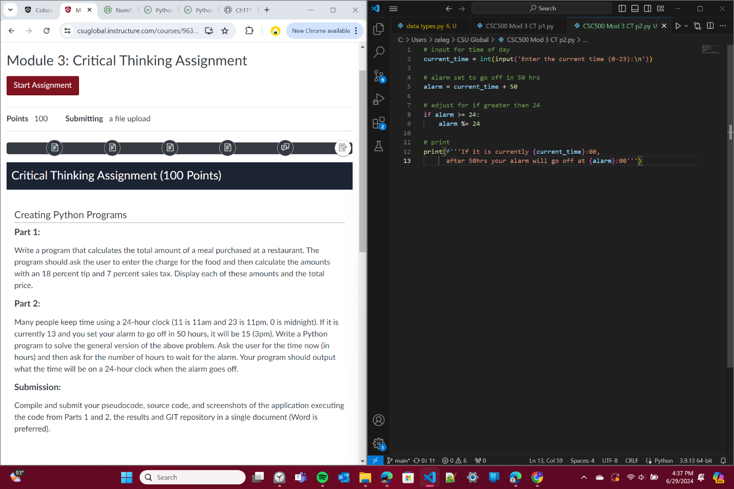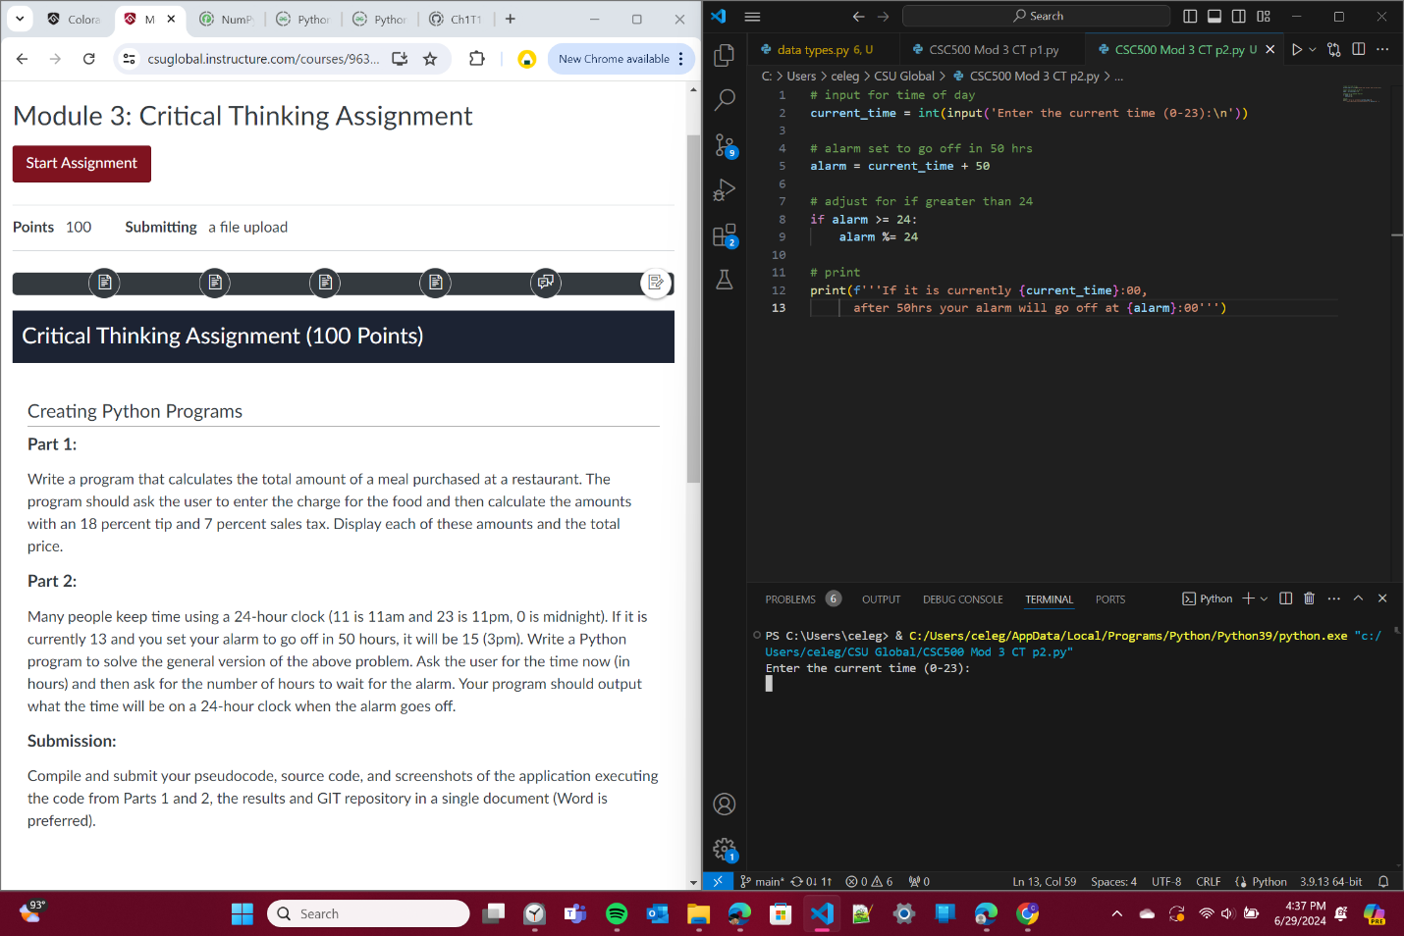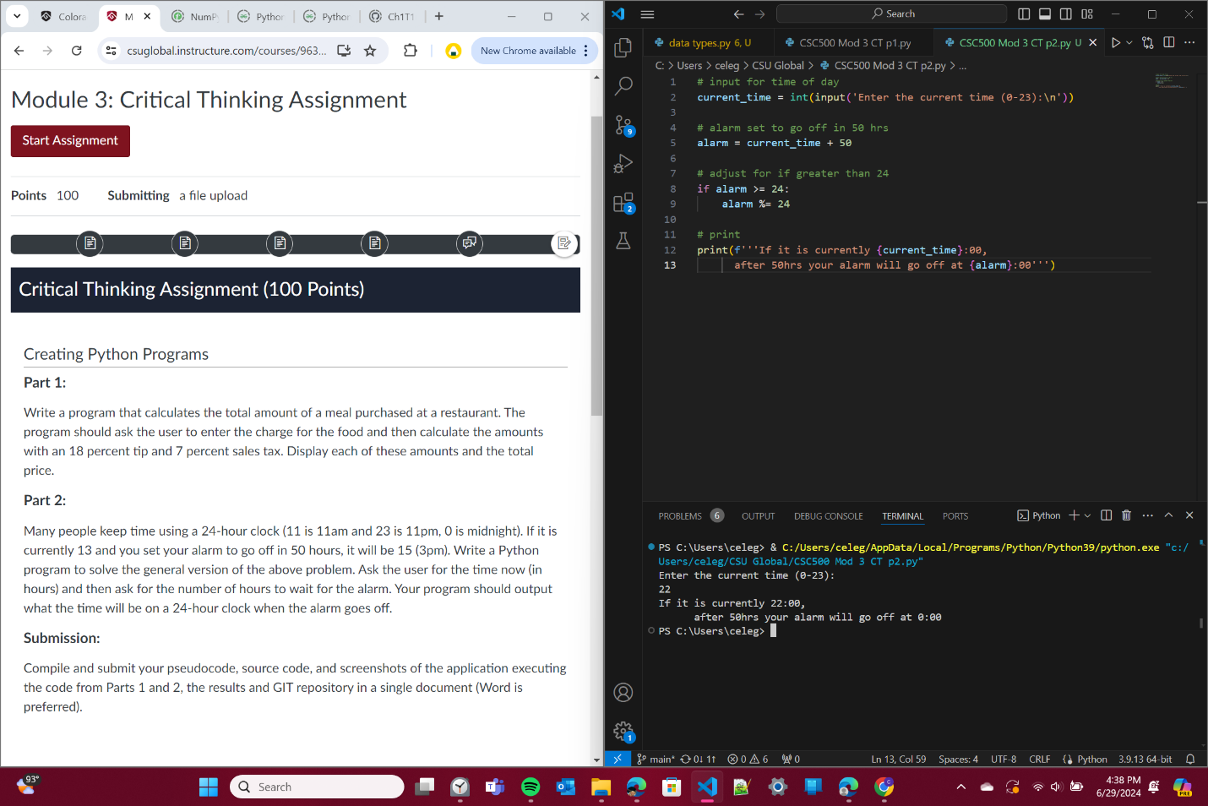

# GIT repository link

<https://github.com/Ch1T1me/CSC500.git>

# Challenges

During this assignment the challenges I faced were in Part 2. I wasn’t sure if I should you and if statement or not. I tried a plain if statement with “If value >= 24 then..” if greater than or equal to 24 hrs then revert back to 0. However, when I ran the code it didn’t turn out as I had hoped.

After thinking about it a bit, I realized I could use the mod. It would calculate the exact number needed without any more hassle. I went back through ZyBooks to help with implementing the mod. The Challenge activity Labs for this week ESPECIALLY helped me out.

# References

ZyBooks: CSC500: Principles of Programming